History of Hydra:
Hydra, a small freshwater commonest polyp, is readily obtainable coelenterate. It serves a good example from the coelenterates to illustrate the fundamental characteristics of Metazoa.
Hydra is represented by several species in the different parts of the world. Some of the common species are H. vulgaris, which is orange-red coloured found in the freshwaters of America and Europe. H. fusca or H. oligactis which is now known as Pelmatohydra is the brown hydra reported chiefly from Punjab in India, North America and Europe.
H. viridis now known as Chlorohydra viridissima is the green hydra of America and Europe. Its green colour is due to the presence of a symbiotic green algae, Zoochlorellae in its endodermal cells. H. gangetica is found in the pond and other water reservoirs along the river Ganges.
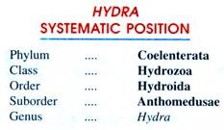

2. Habit, Habitat and Culture of Hydra:
Hydra is found in freshwater ponds, pools, lakes, streams and ditches.
It usually remains attached to submerged vegetation or with any solid object. When it is undisturbed, its body remains extended with tentacles spread out and shows expansions and contraction without any apparent reason. It is carnivorous in habit and feeds on small insects, insect larvae and small crustaceans. It lives singly, i.e., solitary in habit. It reproduces sexually as well as asexually.

Collection and Culture of Hydra:
Hydra can be collected from freshwater lakes, ponds, etc., usually during winter months. If we collect ajar of water with Hydrilla plants and put it undisturbed for a day or two; we may notice a number of Hydra attached either with the wall of glass jar or with the leaves of Hydrilla plant.
These may be examined under microscope by putting them on a glass slide with the help of dropper. For making its culture in laboratory, the same may be transferred in aquarium and a sufficient amount of food must be supplied daily. Its food generally consists of Daphnia readily available in stagnant water. By budding, their number increases very soon in the aquarium.
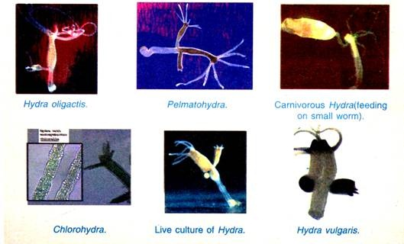

3. Structure of Hydra:

External Structure of Hydra:
(i) Shape and Size:
Hydra is a polypoid coelenterate with a cylindrical body. It is easily visible to the naked eyes and when fully extended, it becomes elongated and slender. It measures from 2 to 20 mm in length. This variation in the length is due to its remarkable power of contraction and expansion.
(ii) Body Form:
Hydra appears tubular. It is sessile but its proximal or aboral end is drawn out into a slender stalk at the end of which is the basal disc or pedal disc for attachment to the substratum.
The pedal disc region of the body is provided with gland cells which secrete adhesive substance for attachment to the substratum and also a gas bubble fox floating. The free distal end or oral end of the body bears a conical elevation called hypostome.
The hypostome bears an aperture at its apex called mouth which opens into the gastro vascular cavity or enteron. The hypostome is encircled by a circlet of 6-10 tentacles (L., tentare = to feel). The tentacles are hollow; their cavity is communicated to the gastro vascular cavity, slender, thread-like processes having nematocysts.
The tentacles can be greatly extended at the time of feeding or locomotion. At the proximal end of the body, it may bear lateral projections called buds in various stages of development. A well developed bud bears its own mouth, hypostome and tentacles.
When the fully formed buds are detached from the parent body, they give rise to new individuals. Gonads may also be present on its body. The testes occur near the oral end which are conical projections, while ovaries are situated towards the proximal end and these are oval projections.
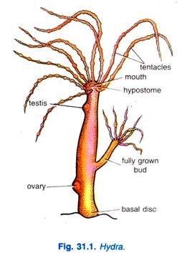

Internal Structure of Hydra:
The internal structure of Hydra can be well explained with its longitudinal and transverse sections. However, the internal structure reveals the presence of body wall and a central cavity extended into the tentacles also called the coelenteron (Gr., koilos = hollow; enteron = gut) or gastro vascular cavity or enteron.
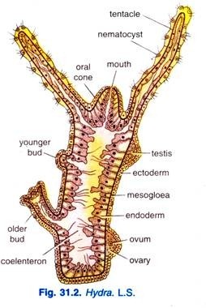

4. Locomotion of Hydra:
Normally, a Hydra remains attached by the basal disc to some suitable object in the water. There it twists about and makes various movements of the tentacles and body in response to various stimuli and for the capture of food. All such movements are caused by the contraction or expansion of the contractile muscle fibres of the muscle processes of both epidermis and gastro dermis.
Actual locomotion is accomplished in several different ways which are as follows:

(i) Looping:
The most common, a type of walking (Fig. 31.15) similar to the looping of an inchworm or caterpillar. While standing erect, the body first extends and then bends and fixes the tentacles to the substratum by means of glutinant nematocysts. It then releases the attachment of the basal disc, reattaches the basal disc near the tentacles and again assuming an upright position by releasing its tentacles.
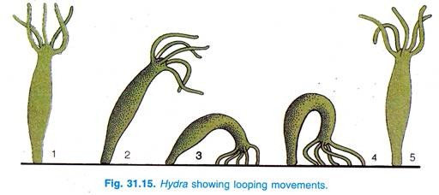

(ii) Somersaulting:
Somersaulting (Fig. 31.16) is like the looping. In this type of movement, Hydra extends its body and is bent to one side to place the tentacles on the substratum, the glutinant nematocysts help to fix the tentacles. The basal disc is freed from its attachment, and the animal stands on its tentacles, the body then contracts strongly till it appears like a small knob.
The body is then extended and bent to place the basal disc on the substratum, the tentacles loosen their hold and the animal regains an upright position. These movements are repeated and the Hydra moves from place to place. This is the normal method of locomotion.
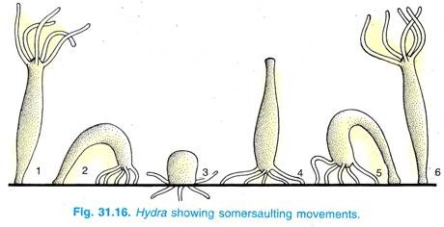

(iii) Gliding:
Hydra can glide slowly along its attachment by alternate contraction and expansion of basal disc.

(iv) Cuttlefish-like movement:
The tentacles are fixed to the substratum and with the pedal disc up, Hydra moves over the substratum by pulling its tentacles along (Fig. 31.17).
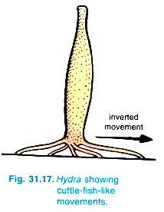

(v) Floating:
Sometimes, Hydra can produce a bubble of gas secreted by some ectodermal cells of the basal disc which helps the animal to float on the surface of the water and is passively carried from one place to another by water current or wind below (Fig. 31.18).
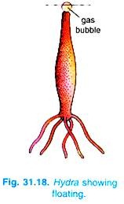

(vi) Climbing:
Hydra can climb by attaching its tentacles to some distant objects and then releasing the basal disc and by contracting the tentacles the body is drawn up to a new position (Fig. 31.19).
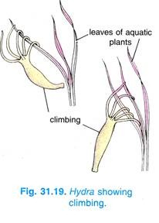

(vii) Swimming:
By freeing itself from the substratum and with the help of wave-like movements of the tentacles, Hydra swims in water.

5. Nutrition of Hydra:

(i) Food and its Ingestion:
The food consists of small crustaceans like Cyclops, small annelids and insect larvae, thus, it is carnivorous. On touching a tentacle by the prey, the stenoteles penetrate it and inject a poisonous toxin to paralyze it, the volvents coil around the bristles to hold the food.
The tentacle holding the captured animal contracts and bends over the mouth, the other tentacles also bend and help to transfer the food into the mouth where it is engulfed by movements of the mouth and hypostome; peristaltic contractions of the body wall force it into the enteron.
Hydra will normally swallow only living prey. It has been shown that it will engulf only those animals which contain a chemical called glutathione which is present in tissue fluids of most animals, and it is released when the body is punctured by stenoteles; this shows that glutathione is necessary to evoke the feeding reaction.
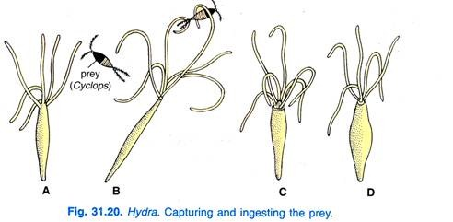

(ii) Digestion of Hydra:
The mucous gland cells of the hypostome cover the engulfed food with mucus, then enzymatic gland cells produce a proteolytic enzyme like trypsin which partly digests the proteins into polypeptides in an alkaline medium in the enteron, this digestion is extracellular.
Some endoderm cells form pseudopodia and engulf the smaller partly digested particles into food vacuoles. The contents of the food vacuoles are first acidic, then they become alkaline, the remaining digestion is completed in the vacuoles, and it is called intracellular digestion.
Thus, Hydra combines the intracellular digestion of Protozoa and extracellular digestion of higher animals. Some endoderm cells after taking in food into food vacuoles separate from the body wall and wander about in the enteron to the parts where digested food is needed.
Digested food is assimilated to endoderm cells and transferred to ectoderm or into the enteron from where it is distributed to all parts; thus, the enteron cavity serves a double function of digestion and circulation. Hydra can digest proteins, fats and some carbohydrates, but it does not digest starch. Some digested food forms oil globules which are stored in the ectoderm.

(iii) Egestion:
The indigestible materials, like exoskeleton of crustaceans, are ejected through the mouth on contraction of the body. The mouth, thus, functions as anus also.

6. Respiration, Excretion and Osmoregulation of Hydra:
There are no special organs for respiration and excretion. Gaseous exchange occurs through the general body surface. Nitrogenous wastes are largely in the form of ammonia, which also diffuses through the general body surface. It is also thought that the gastro dermis of basal disc is said to accumulate some excretory matter, which may be discharged through a pore.

Osmoregulation of Hydra:
The water that continuously enters into the body cells by endosmosis is finally collected into the gastro vascular cavity and from here expelled out through mouth due to a wave of muscle contraction passing from the basal disc region to the hypostomal region.

7. Nervous System of Hydra:
There are many nerve cells, each with two to four branching nerve fibres. The nerve fibres are primitive because they do not form axons or dendrites, moreover the nerve fibres form actual contacts with fibres of other nerve cells. Recent studies have shown that there are no synapses, thus, they form a continuous nerve net (Fig. 31.21).
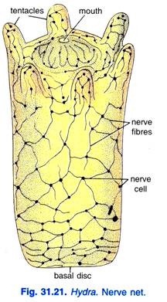
In Hydra, there are two nerve nets, one in connection with the ectoderm which is more highly developed, and the other near the endoderm, the two nerve nets lie in and on either side of the mesogloea. But the ectodermal nerve net is more strongly developed and is particularly concentrated around the mouth and basal disc regions.
The two nerve nets are joined to each other and to the sensory cells of both ectoderm and endoderm, they are also joined to the epitheliomuscular cell. The fibres of both nerve nets are continuous and there are no synapses. Sensory cells are receptors for touch, light and chemicals, and stimuli pass from them through the nerve nets to muscle processes which act as effectors.
This is a diffused nervous system which works as a receptor → conductor → effector system. The nerve cells form conducting chains between receptors and effectors. The messages radiate in all directions from the point of stimulation but there is no coordination because the messages do not evoke responses equally in all the effectors.

8. Behaviour of Hydra:
The movements of Hydra connected with feeding are automatic, they are governed by the external environment. It responds to contact, if a tentacle is touched then the other tentacles and even the body may contract; this shows that there is a transmission of the stimulus, the stimulation is conducted in all directions by the nerve nets.
The response is greatest near the point of stimulation and it gets progressively less in more distant regions because each nerve net offers some resistance to the passage of impulses, this resistance occurs at the numerous nerve cells. Hydras are found more towards the top of a pond than at great depth, thus, they can obtain more oxygen.
If Hydra is attached near the bottom, then the body is held upright, but at average depth it is horizontal with the hypostome lower than the foot. It also hangs with the head down by its foot from the surface of water with the aid of a gas bubble. It can alter the shape of the body becoming long and slender or small and contracted like a barrel.
Behaviour of Hydra depends on its physiological state, the response of a well-fed Hydra to stimuli is slow and sluggish, but a hungry Hydra will respond vigorously to the same stimuli.
However, Hydra responds to various stimuli in the following way:

(i) Light:
Hydra shows positive response to mild light but avoids or shows negative response to both strong light or very less light. Actually, it becomes restless and moves in a number of directions in darkness.

(ii) Temperature:
Hydra prefers mild temperature which suits best for its life activities, say from 20 to 25° C. Any increase or decrease from these levels in temperature is avoided by Hydra.

(iii) Electricity:
Hydra reacts to weak constant electric currents by bending towards the anode and then contracting the entire body. If attached by the basal disc, the oral end bends towards the anode but if fixed by tentacles, the basal disc bends towards the anode side.

(iv) Chemicals:
Hydra always shows negative response to injurious chemicals but exhibits positive response to food.

9. Reproduction in Hydra:

(i) Asexual Reproduction of Hydra:
Hydra reproduces asexually by budding. In fact this is the usual means of reproduction during the warmer months of the year.
Asexual Budding:
A bud (Fig. 31.22) develops as a simple evagination of the body wall. The ectoderm cells increase in number at one point to form a protuberance below which the endoderm cells acquire reserve food, then both ectoderm and endoderm are pushed out to form a bud which contains a diverticulum of the enteron.
The bud arises at the junction of the stalk and stomach, and several buds may be formed at the same time. At the distal end, the bud grows tentacles one by one and a mouth is formed. The attachment of the bud to the mother Hydra constricts to separate the bud, but endoderm cells at the base unite before this, after constriction ectoderm grows over the foot to cover the endoderm.
The bud grows into a new Hydra which migrates towards the surface of water for dispersal, but it finally gets fixed by its basal disc so that it becomes a solitary individual. Budding occurs during the warmer months when food is plentiful.
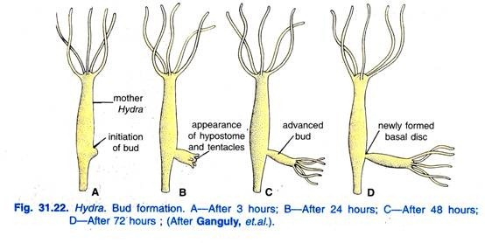

(ii) Sexual Reproduction of Hydra:
In Hydra, it starts with the development of temporary structures called gonads during autumn months. Actually, sexual reproduction occurs during the un-favourable conditions like excessive high and low temperatures of the water in which Hydra lives or also due to an increase in the amount of free carbon dioxide in the surrounding water.
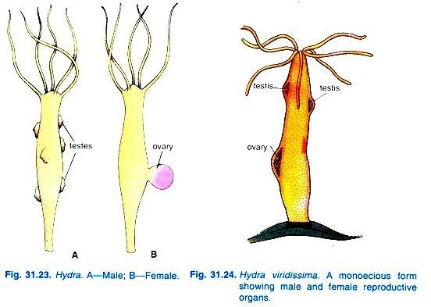
Generally, the gonads develop due to the repeated proliferation of the interstitial cells of the epidermis which form bulging’s on the body wall. The bulging’s of gonads differ from the bulging’s of buds as the mesogloea and gastro dermis do not enter into the gonads.
Mostly, the species of Hydra are dioecious, i.e., sexes separate; the individuals bear either male or female gonad, e.g., H. oligactis. But some species are monoecious or hermaphrodite also, i.e., both male and female gonads are found on the body of same individual, e.g., H. viridissima. Usually, the testes develop towards the distal part of the body, while ovaries develop towards the proximal part of the body.
In H. oligactis, where sexes are separate, male and female can be marked easily. The males are smaller and bear 1-8 conical testes having a teat-like structure over them. The females are comparatively longer and bear 1-2 oval ovaries.
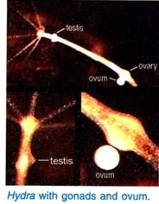
Testes and Spermatogenesis:
The interstitial cells of epidermis multiply rapidly to increase in number and finally push out the other cells of epidermis to form swellings on the outer body surface of Hydra. Thus, the structure formed is called testis. The testes are rounded spherical structures in dioecious forms, while they are blunt conical structures in monoecious forms. Now, the interstitial cells start behaving like sperm mother cell or spermatogonia.
These divide to form secondary spermatogonia which develop into spermatocytes. The spermatocytes undergo two maturation divisions, one being reduction division to form spermatids. The spermatids then differentiate to form spermatozoa.
Each spermatozoa being haploid carries 15 chromosomes in H. oligactis and possesses a cylindrical head containing nucleus, a middle piece and a vibrating long tail. Due to the pressure of spermatozoa in testis, its wall ruptures to release spermatozoa in the surrounding water.
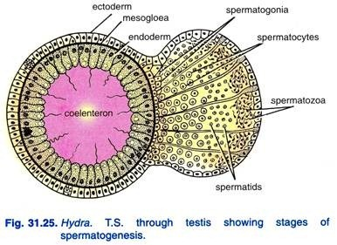
Ovary and Oogenesis:
The ovary also develops in the same way as testis from the interstitial cells of the epidermis.
The interstitial cells behave like oogonia. Now, one of the oogonia, usually that which is centrally located, becomes larger and amoeboid called oocyte. The other oogonia are used up as nourishment and for forming yolk. The oocyte undergoes two maturation divisions, one of them being reduction division to form a large yolk-laden ovum and two polar bodies.
The ovum being haploid contains 15 chromosomes in H. oligactis. The ovum is a large yolk-laden mass occupying most of the space inside the ovary. The ovum remains surrounded by epidermal cells in the beginning but when it matures the epidermal cells break up and withdraw.
Thus, the ova becomes naked on all sides except where it is attached to the body of. Hydra by an epidermal cup. Each ovary produces a succession of ova but usually one at each time, sometimes there are found two in H. viridissima or more in H. dioecia. The ovum remains attached with the parent body and secretes a protective gelatinous sheath around it.
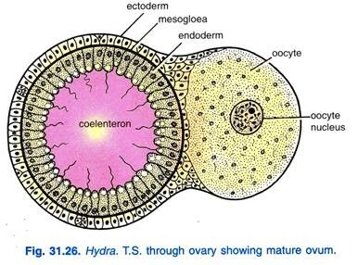
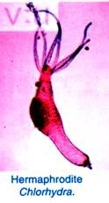
Fertilisation:
Cross-fertilisation occurs as a rule in the different species of Hydra. To avoid self-fertilisation, even in monoecious species, the testes mature first, i.e., protandrous condition exists. However, fertilisation takes place when mature spermatozoa released from testes approach randomly to the naked ovum surrounded in gelatinous sheath.
Many sperms may penetrate the gelatinous sheath to reach the ovum but only one of them reaches to the ovum and fuses with it completely to form the zygote which becomes diploid with 30 chromosomes. The process of fertilisation takes place effectively only when the sperm reaches the ovum within its viable condition; that usually remains for two hours from its being exposed to naked otherwise it perishes.
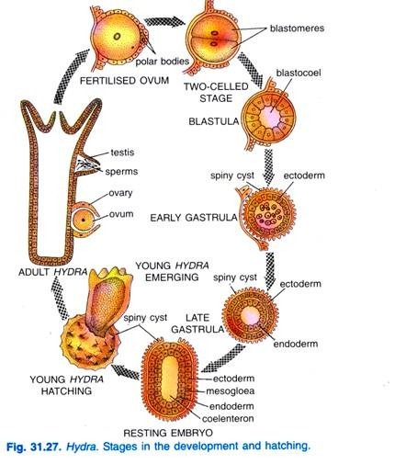
Development:
The development of zygote starts soon after fertilisation when it still remains attached to the parent body. The zygote undergoes total equal cleavage, i.e., holoblastic to form a hollow ball of cells. The cells are called blastomeres which soon get arranged to form a single layered embryo with a central cavity called blastocoel. The embryo is now known as blastula.
The cells of blastula divide rapidly and some of them delaminate into the blastocoel to completely obliterate it.
Now the embryo is called gastrula which has an outer layer of cells, forming ectoderm and an inner core of cells, forming endoderm. The solid gastrula is neither ciliated nor free swimming because it is still attached to the parent body. This type of gastrula is characteristically called stereo gastrula which represents the planula stage of Hydra.
The outer ectodermal layer of the embryo soon secretes some secretion which hardens to form a protective covering round it called theca. The theca is two-layered being formed of an inner thin membrane and outer thick and chitinous layer. The theca may be smooth as in H. oligactis or spiny, it may be oval or round.
At this stage, the embryo gets detached from the parent body, settles at the bottom and remains dormant till the advent of favourable environmental conditions. After the approach of favourable conditions, the embryo again becomes active and development starts. The endodermal cells get arranged into a layer beneath the ectodermal layer and, thus, a new cavity called coelenteron or gastro vascular cavity appears.
A layer of mesogloea develops between ectoderm and endoderm. These two germ layers, i.e., ectoderm and endoderm give rise to their different derivatives, a circlet of tentacles develop, hypostome and mouth is formed. Thus, a young Hydra is formed.
Hatching:
With the above developments, the embryo increases in size and the theca ruptures to release young Hydra resembling a polyp. It soon elongates and gets fixed by its aboral end and grows into an adult.

10. Regeneration of Hydra:
Regeneration may be defined as the ability of certain animals to restore the lost or worn out parts of their bodies. Hydra has the considerable power of regeneration. Trembley (1744 or 1745) first of all demonstrated that an individual Hydra can be cut into several pieces, and each will regenerate the lost parts, developing a whole new individual.
The parts usually retain their original polarity, with oral ends developing tentacles and aboral ends, basal discs.
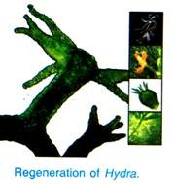
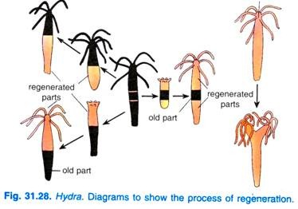
Parts of two different individuals, often of different species, may be brought together and grafted together in various arrangements. The germ layers, however, will not mix. The epidermis will only fuse with epidermis and gastro dermis with gastro dermis.
Trembley (1744 or 1745) also demonstrated that if the head end of Hydra is split into two and the parts are slightly separated it results into a Y-shaped Hydra or two-headed individual having two mouths and two sets of tentacles. Each head may be again split in a similar manner. In this way Trembley succeeded in producing a seven-headed Hydra.
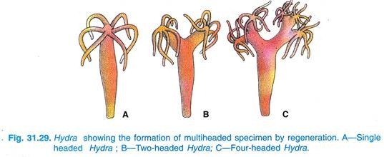
Occasionally, even in nature, a Hydra becomes turned inside out. In the laboratory this can be accomplished mechanically or by overdoses of glutathione. Trembley (1744) thought that under these conditions the epidermis becomes gastrodermis and gastrodermis becomes epidermis.
More modern studies, however, demonstrate conclusively that this does not occur. Rather, the Hydra usually turns itself right side again, but if it does not, the layers switch location by migration of cells through the mesogloea.

11. Immortality of Hydra:
Brien (1955) and others have found that a Hydra is at least potentially immortal. There is a growth zone just below the base of tentacles in which interstitial cells give rise to new body cells of all types.
As these new cells are formed, other cells are pushed toward the end of the tentacles or the basal disc where the old cells are shed. In this manner all of the cells are renewed once in about 45 days. So far as is known, this process of cell replacement continues indefinitely. If the interstitial cells of growth zone are destroyed by X-rays, the Hydra lives only a few days.
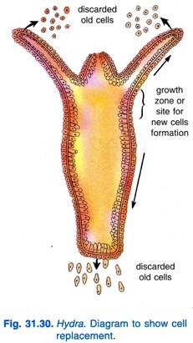

12. Symbiosis in Hydra:
Symbiosis (Gr., sym = together + bios = living) is an association of two different species of individuals in which both the partners are benefited.
The degree of association in a symbiotic relationship varies from rather loose associations in which the two partners benefit relatively little from each other, to a very intimate association in which the two partners may be regarded as a single organism.The green Hydra, Chlorohydra viridissima exhibits a very good example of symbiosis.
The gastro dermal cells of. C.viridissima are harboured by a large number of unicellular green alga Chlorella referred as Zoochlorella in this case (or Zooxanthelld).
The algae are passed from one generation of Hydra to the next through the eggs. It seems impossible to deprive a Chlorohydra of its Zoochlorella and, thus, it is evident that they are mutually benefited; the alga gets shelter and protection and also at the same time obtains carbon dioxide from hydra’s respiration and nitrogenous compounds from its excretory wastes, in return the Hydra obtains oxygen and carbohydrates from alga due to its photosynthetic activity.
In this association, one individual in which other harbours are called host and symbiont respectively.

13. Physiological Division of Labour in Hydra:
H.M. Edward, a French scientist advocated that even the primitive multicellular animals exhibit physiological division of labour like those of higher Metazoa and human society. We know that in human society different set of people like washer man, cobbler, blacksmith, carpenter, potter, farmer, teacher, doctor, engineer, etc., perform different functions for the society; they are specialised to do their jobs efficiently.
Likewise, for proper functioning of a multicellular body the different life activities are performed by different cells present in its body. Certain cells become specialised for one function, others for different functions unlike to that of a unicellular body in which all life activities are performed by the single cell.
In lower Metazoa, similar cells performing similar functions form tissue, while in higher Metazoa, similar tissues together constitute an organ and similar organs performing similar functions form systems. All these are specialised to do their jobs efficiently. This is called physiological division of labour where different cell types are specialised structurally and physiologically to perform different functions.
This phenomenon is well illustrated by coelenterates. Hydra, however, exhibits it but still at a primitive level.
We have noted that the ectoderm of Hydra is protective, muscular and sensory,its nematocysts are used for defence and for obtaining food. The ectoderm of basal disc is glandular which helps in fixing the Hydra with the substratum; its central part can produce gas bubble which helps in floating. The endoderm is digestive, vascular, muscular and also secretory.
The interstitial cells form gonads and replace both ectodermal and endodermal cells. The enteron carries on digestion and circulation. The mouth serves for ingestion of food and egestion of wastes.
The tentacles are used for obtaining food and for locomotion. All this division of labour is possible because Hydra is beginning to show a differentiation of its parts. Thus, it can be said that the physiological division of labour is correlated with a morphological differentiation of structure.

